<page_start no = 1>
<sol_start id=1>
1. (3) 3
<sol_end>

<sol_start id=2>
2. tan 60°
<sol_end>

<sol_start id=3>
3. 100°
<sol_end>

<sol_start id=4>
4 10 cm
<sol_end>

<sol_start id=5>
5 a = 0
<sol_end>

<sol_start id=6>
6. Four decimals places
<sol_end>

<sol_start id=7>
7. 3 and 1
<sol_end>

<sol_start id=8>
8. (0, –1)
<sol_end>

<sol_start id=9>
9. No solution
<sol_end>

<sol_start id=10>
10.
<sol_end>
<page_end>

<page_start no = 2>
<sol_start id=11>
11.
<sol_end>

<sol_start id=12>
12. 8
<sol_end>

<sol_start id=13>
13. similar
<sol_end>

<sol_start id=14>
14. x³y⁴z⁴
<sol_end>

<sol_start id=15>
15. u²–u+12
<sol_end>

<sol_start id=16>
16. Intersecting coincident
<sol_end>

<sol_start id=17>
17. Parallel
<sol_end>

<sol_start id=18>
18. 16 : 81
<sol_end>

<sol_start id=19>
19. Both AUR are correct but R is not the correct explanation of A.
<sol_end>

<sol_start id=20>
20. A is false but R is true.
<sol_end>
<page_end>

<page_start no = 3>
<sol_start id=21>
21. 6×5×4×3×2×1+5
5
125
5
145
29
29
1
= 5×5×29
Since it is the product of the prime it is a composite number.
<sol_end>

<sol_start id=22>
22. 4x + 6y = 7 , kx + 18y = 21
6k = 72
k = 12
k should be equal to 12.
<sol_end>

<sol_start id=23>
23. (0, 0), (–6, 8)
= 10
<sol_end>
<page_end>

<page_start no = 4>
<sol_start id=24>
24. sin 3A = cosA–10
= cos90–3A = cosA–10
Sinθ = cos90°–0
90–3A = A·10
90+10 = A+3A
4 A = 100
<sol_end>
<sol_start id=25>
25. ∠AOB = ∠DOC [Vertical angls]
∠OAB = ∠ODC [Alternate angls]
∠ABO = ∠DCO [ ,, ,, ]
from A – A – A
<sol_end>

<sol_start id=26>
26. W.K.T
cos(90·0) = sinθ
sin(90·0) = cosθ
tan(90·θ) = cotθ
= sin(50+θ) = cos(40–θ) = tan 1×tan10
tan20 × tan70 × tan 80 × tan 89
= cos(40–θ)–cos(40–θ)+cot89°×cos80°×cot70°×tan70°×tan80°×tan89°
= cot89·cot80·cot70·tan70·tan80·tan89
so
Hence proved.
<sol_end>

<sol_start id=27>
27. It stats that if a line is parallel to the side of a triangle which intersects the other side into two distinct point then the line divide those side of the triangle in propotion.
Let ABC be a triangle
To prove
Join BE, CD
Draw
Since
EF is the height of triangle ADF & ABE
Area of triangle
……(1)
Similarly
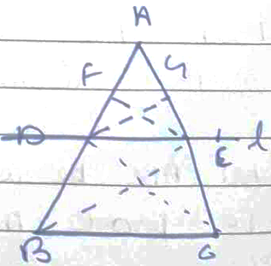
……(2)
Ar(DBE) = Ar(DCE) ……(3)
From (1) (2) (3) we have
<sol_end>
<page_end>

<page_start no = 5>
<sol_start id=28>
28. Let Sagar age be = x
Let Tiru age be = y
2(5–x) = (5–y)
10–2x = 5–y
–2x + 5 + y
–2x + y + 5 = 0 …..(1)
–2x + y = –5
(10 + x)+10 = (10+y)
20 + x = 10 + y
x – y + 10 = 0 …..(2)
x – y = 10
comparing (1) & (2)
–2x + y + 5 = 0
x – y + 10 = 0
–x + 15 = 0
–x = –15
x = 15
15 – y = –10
– y = –25
y = 25
Age of Sagar = 15
Age of Tiru = 25
<sol_end>
<page_end>

<page_start no = 6>
<sol_start id=29>
29. A(–5, 7), B(–4, 5), C(–1, –6), D(4, 5)
Join A to C
∴ Ar(ABCD) = Ar(ABC) + Ar(ADC)
Area of
sq. unit
Ar of
= [Area can be negative)
sq. units
Ar(ABD) =
272 sq. unit
= 72 sq. unit
<sol_end>

<sol_start id=30>
30. 31353 = 861 × 1 + 492
861 = 492 × 1 + 369
<sol_end>

<sol_start id=31>
31. Let the poin P(x, 0) is equ distant from the pts.
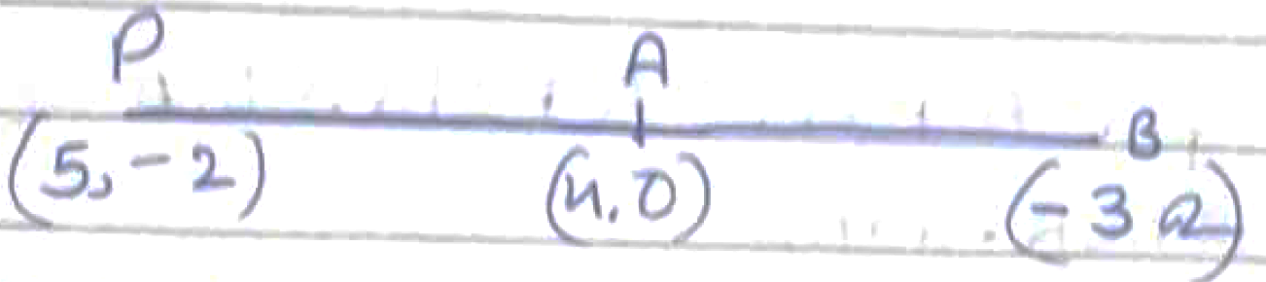
i.e = AP = BP
AP² = BP²
(5–x)² + (–2, –0)² = (–3–x)² + (2–0)²
= x² + 25 –10x + 4 = x² + a + 6x + 4
= 10x + 6x + a + 4 –4z–25 = 0
16–16 = 0
So (1, 0) is the point.
<sol_end>
<page_end>

<page_start no = 7>
<sol_start id=32>
32. tanA + sinA = m
tanA – sinA = n
m² = (tanA + sin)² = tan²A + sin² + 2 tanA ×sinA
n² = (tanA–sin)² = tan²A + sin² A –2 × tanA × sinA
= m²–n² = tan²A + sin² A + 2ta·sinP–(ta²A+sin²A–2taA·sinA)
= 4 tan A·sin
mn = (tanA + sinA) (tanA–sinA)
= tan²A–sin²A =
= sin²A(sec² A–1)
W.K.T.
Sec²A – tan²A = 1
= sin² A × tan² A =
LHS = 4RHS
m²–n² =
<sol_end>
<page_end>

<page_start no = 8>
<sol_start id=33>
33. x–y+1 = 0
y = x + 1
put x = –1
y = 0
put x = 1
y = 2
put x =2
y = 3
x | –1 | 1 | 2
y | 0 | 2 | 3
3x + 2y – 12 – 0
2y = (–3x + 12
Put x = 0
6
X | 0 | –2 | 4
Y | 6 | 3 | 0
x = 2
x = 4
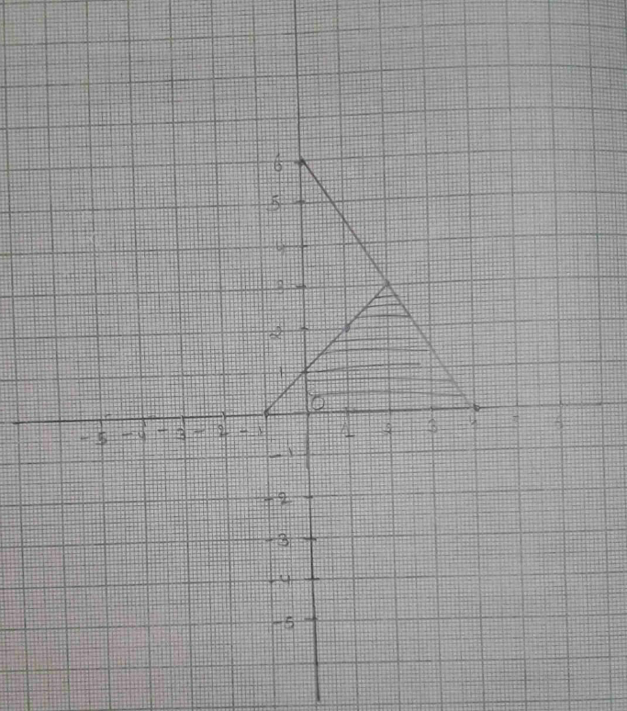
= Area of triangle
= 7.5 sq. unit
<sol_end>

<sol_start id=34>
Q.34 p(x) = 2x³ –4x –x²+2
Two zeros are
x²–2 is the factor of p(x)
Apply the division Algorithm
p(x) 2x³–4x–x²+2 & x²–2
remainder r = 0
p(x) = q(x) × g(x)
∴ 2x³ 4x – x² + 2 = (x²–2)(2x–1)
=
=
= ,
<sol_end>
<page_end>

<page_start no = 9>
<sol_start id=35>
35. 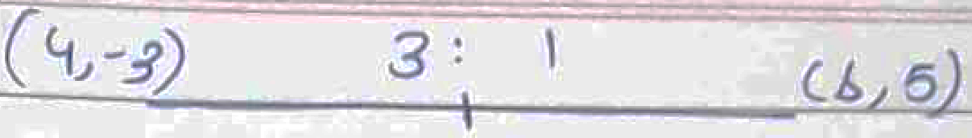
P(7, 3) is the required point.
<sol_end>

<sol_start id=36>
<sub_id = 1>
36. (i) (0, 10)
<sub_id end>
<sub_id = 2>
(ii) (3, 5)
<sub_id end>
<sub_id = 3>
(iii) 4m
<sub_id end>
<sol_end>

<sol_start id=37>
<sub_id = 1>
37. (i) Parabola
<sub_id end>
<sub_id = 2>
(ii) 1
<sub_id end>
<sub_id = 3>
(iii) –3, 2
<sub_id end>
<sol_end>

<sol_start id=38>
<sub_id = 1>
38. (i) 24 cm²
<sub_id end>
<sub_id = 2>
(ii) RHS
<sub_id end>
<sub_id = 3>
(iii) 16:81
<sub_id end>
<sol_end>
<page_end>

